# Our solarsystem

Our solarsystem near <> far from the sun:

* Mercury
* Venus
* Earth
* Mars
* Jupiter
* Saturn
* Uranus
* neptune

**Visual layers**

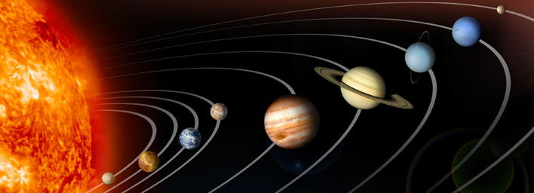

**Layers with their 3d place**

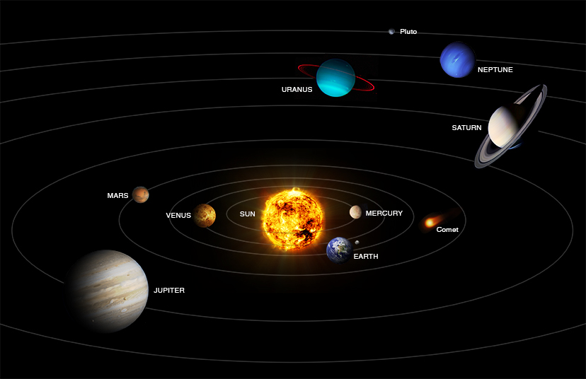

# Our planets specs

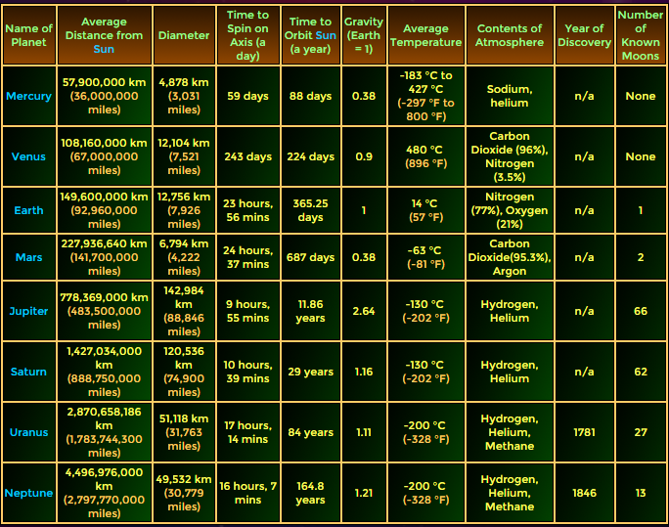

src: <http://www.bobthealien.co.uk/table.htm>

# Another source + some ‘nice to know things’

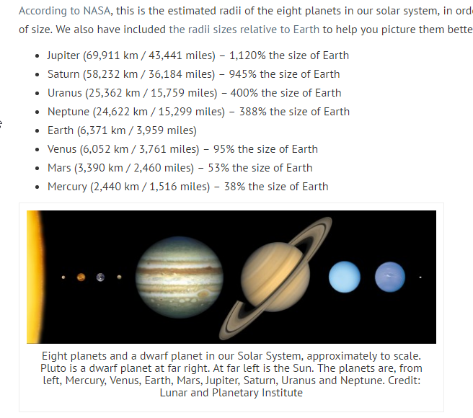

src http://www.universetoday.com/36649/planets-in-order-of-size/